Appleby United Church
SATURDAY OCTOBER 24, 2026
8:30AM – 11:30AM
FALL RUMMAGE SALE
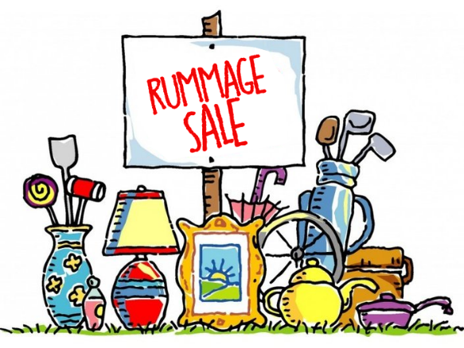
CLOTHING • BOOKS & TOYS • HOUSEHOLD ITEMS LINENS/CRAFTS - SMALL APPLIANCES & FURNITURE – ELECTRONICS, COMPUTERS & ACCESSORIES
BARGAINS GALORE!

Come & Visit These Specialty Areas –
Twice-As-Nice Boutique, Computer Cove, China Cupboard, Beads & Baubles
***********************
Visit the Appleby Café for refreshments & tasty treats


4407 Spruce Avenue, Burlington • Tel.: 905.637.2942 E-mail: applebyoffice@applebychurch.ca • Applebychurch.ca

